
American International University – Bangladesh
Faculty of Engineering
Department of EEE & CoE

MICROPROCESSOR & EMBEDDED SYSTEM PROJECT PROPOSAL FORM
- SEMESTER: Spring 2021-2022

PROJECT TITLE: GSM based fire controlling system using Arduino uno board
- Survey to develop process for complex engineering problems considering cultural and societal factors (use pie chart):
This survey was conducted to develop the process for complex engineering problems considering cultural and societal factor where 57 people participated. The result of the survey is given below.
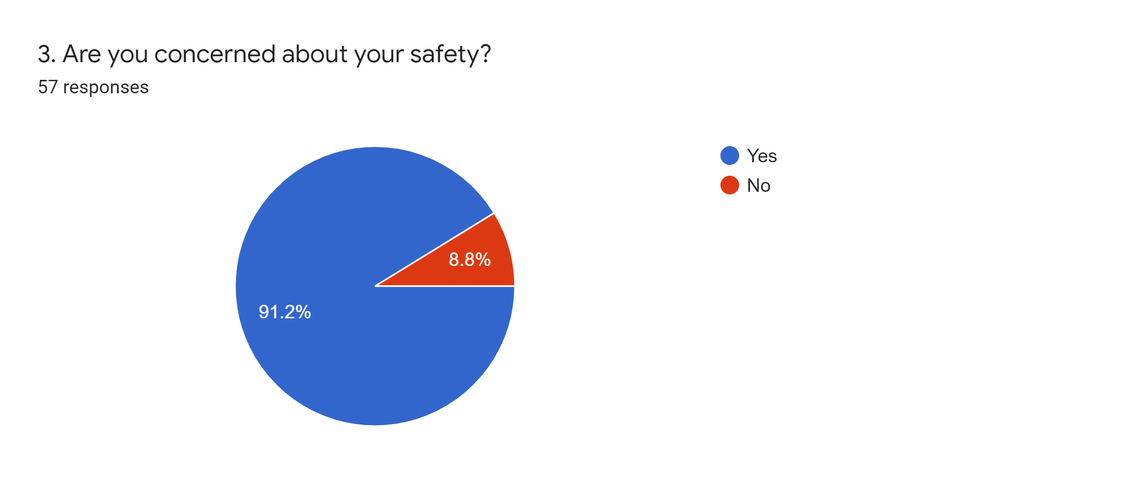
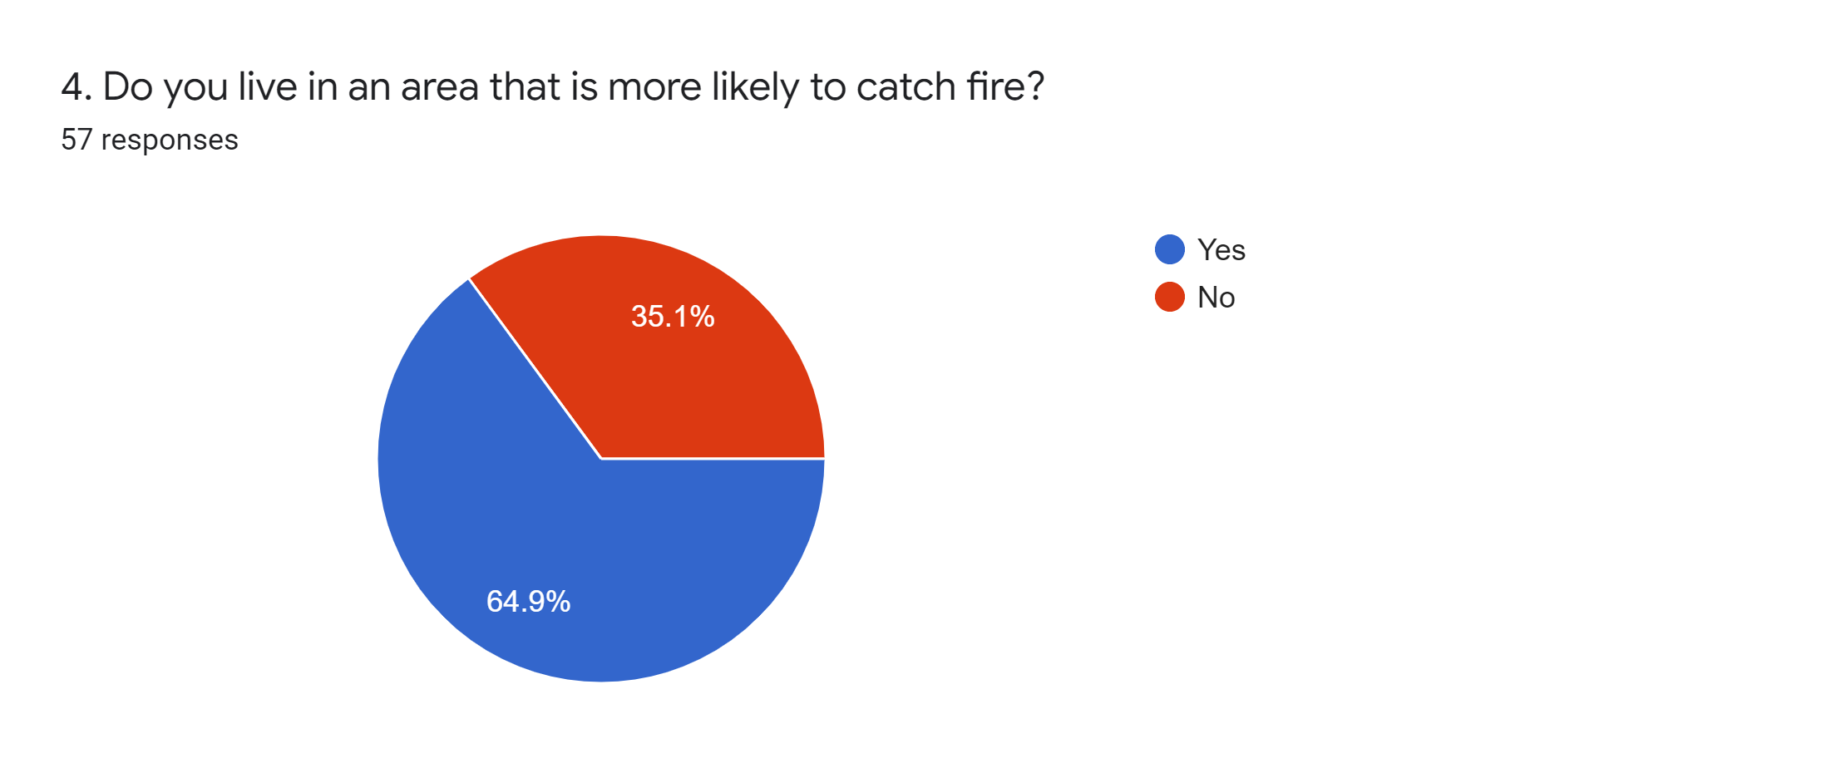
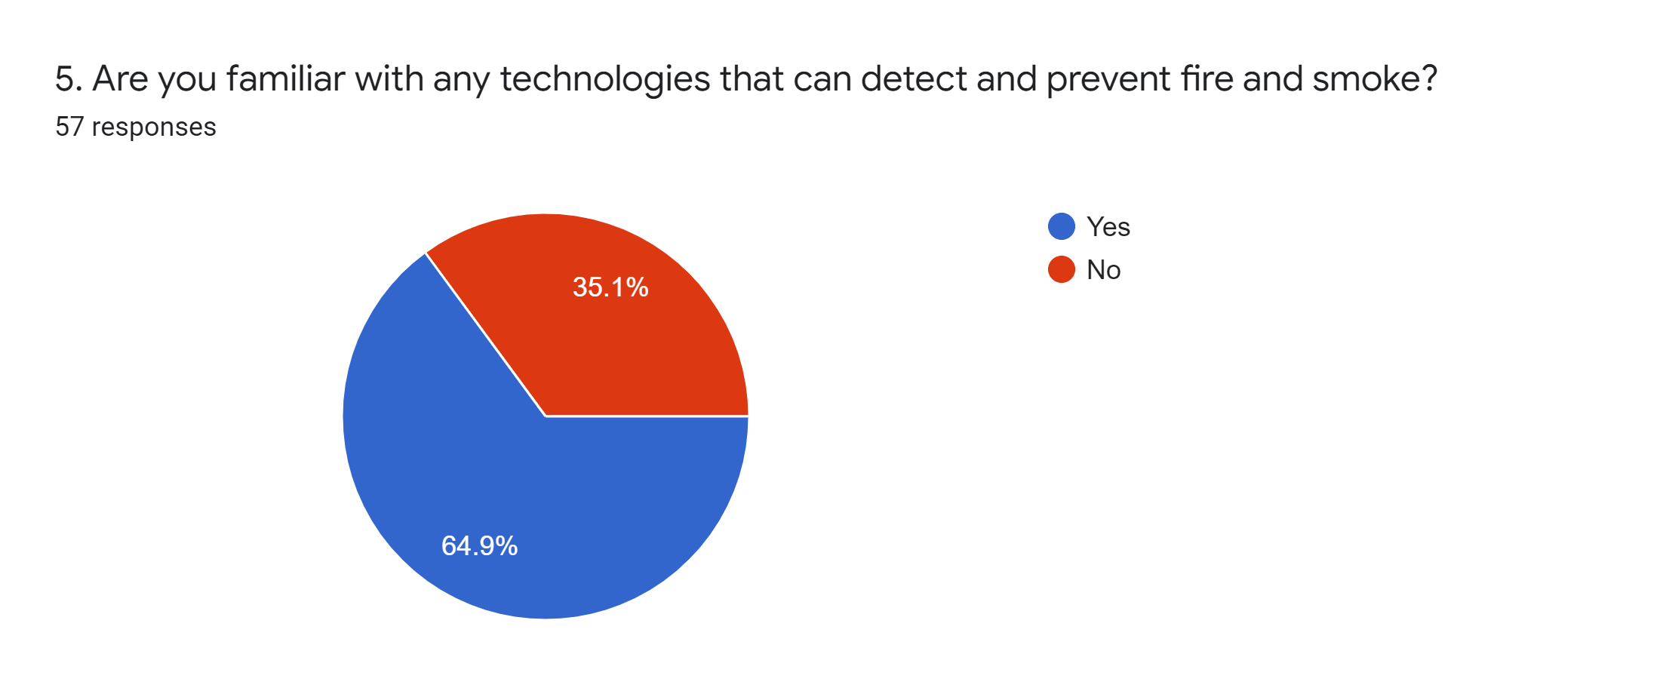
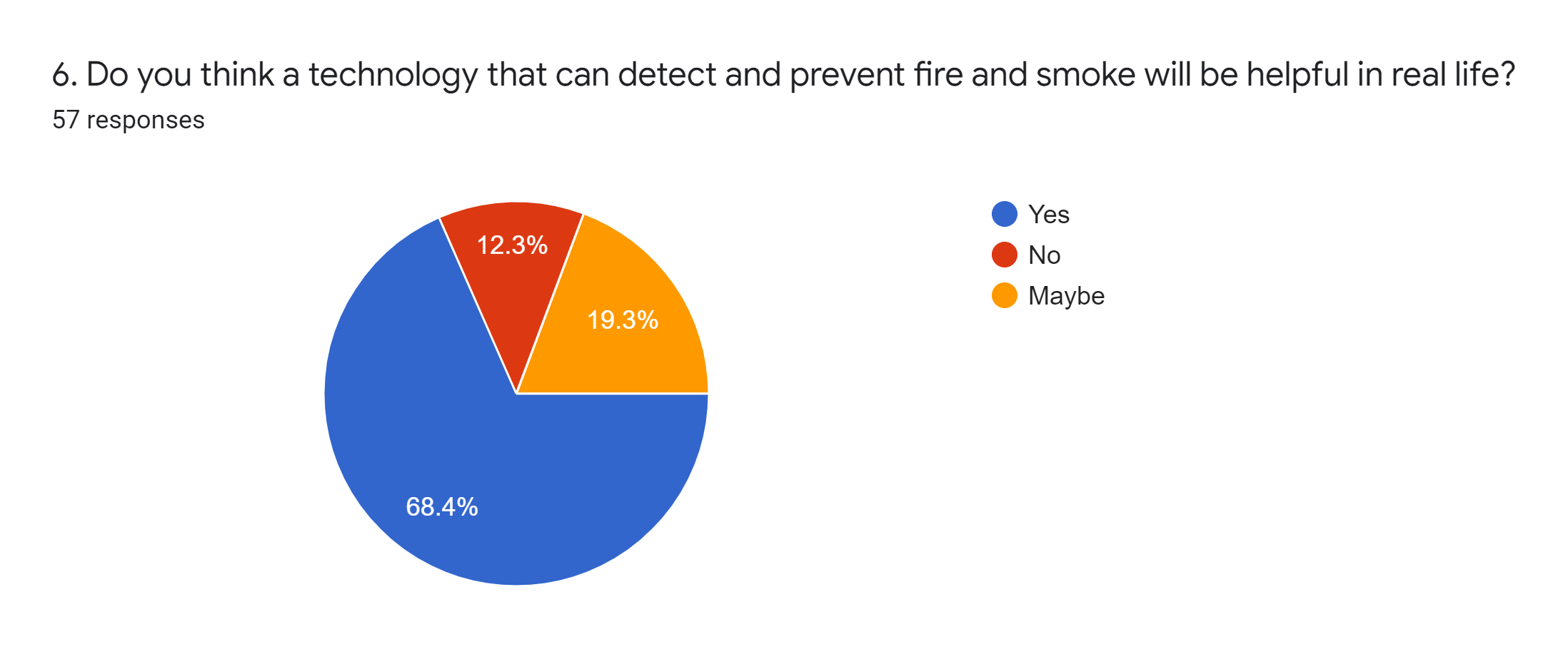
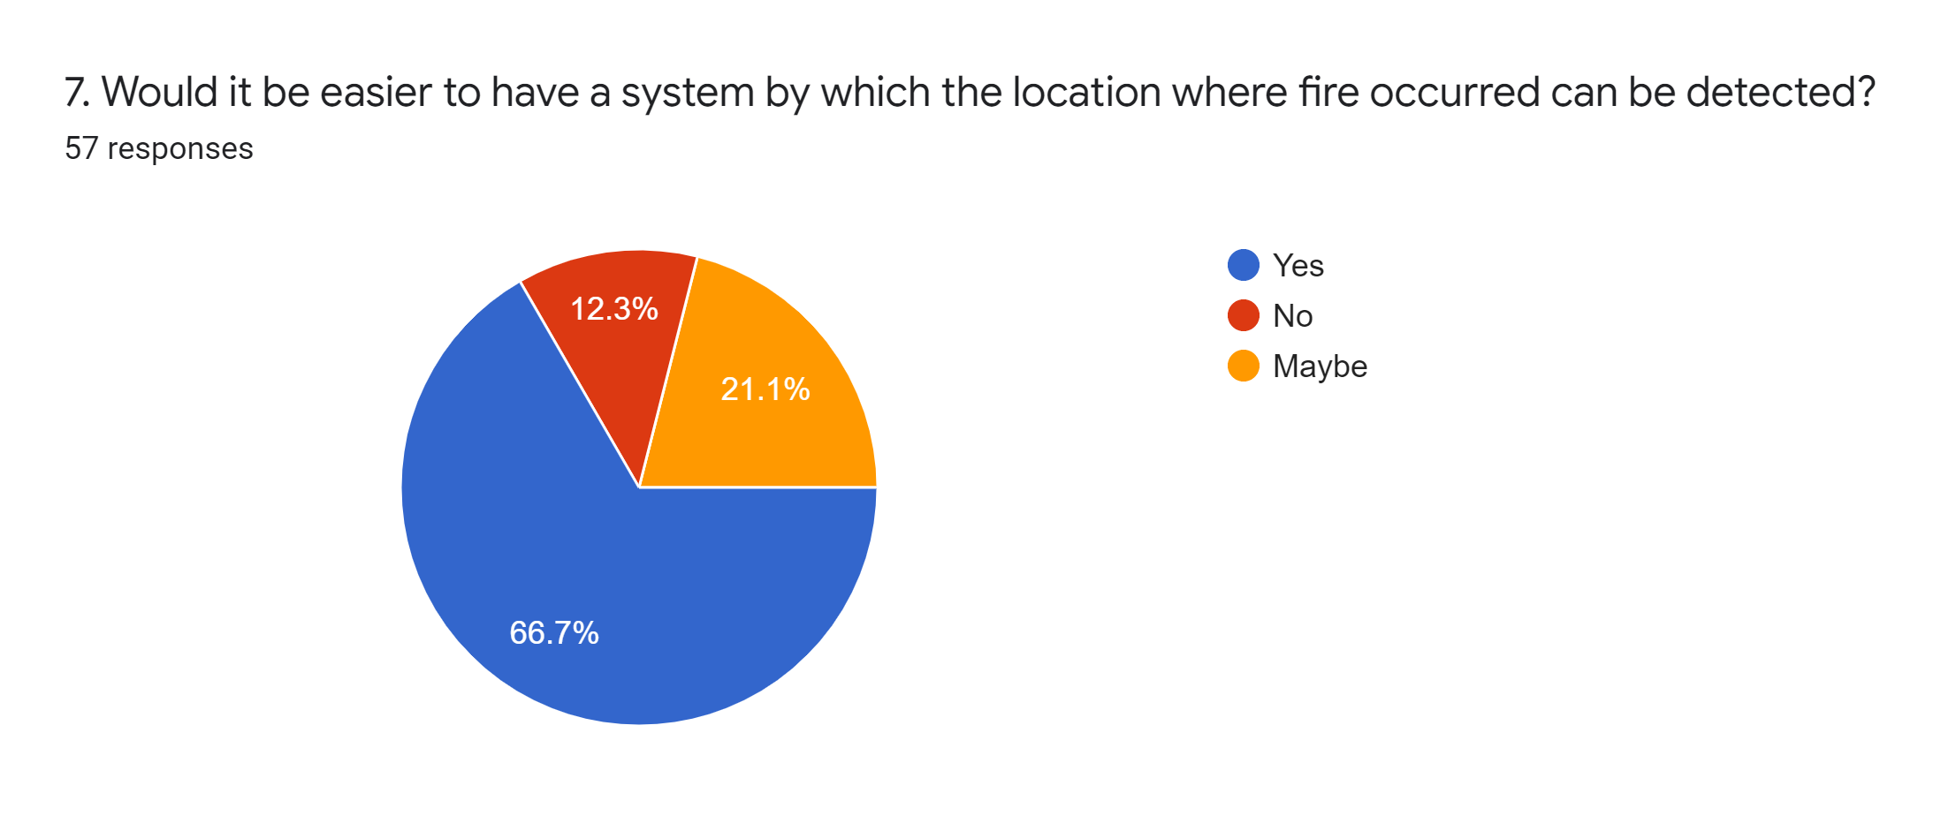
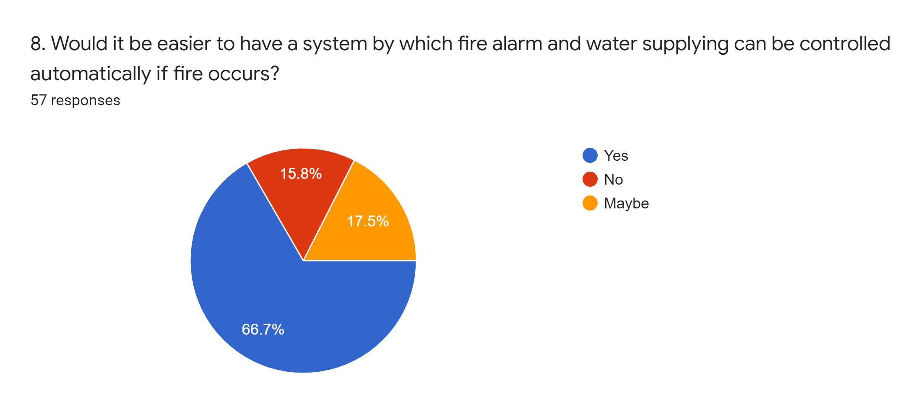
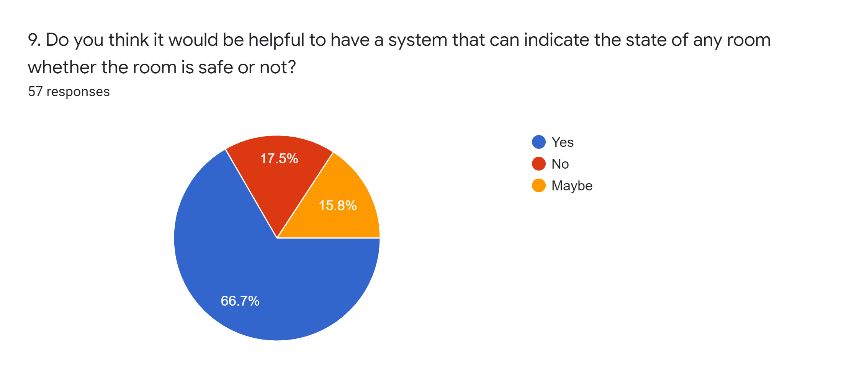
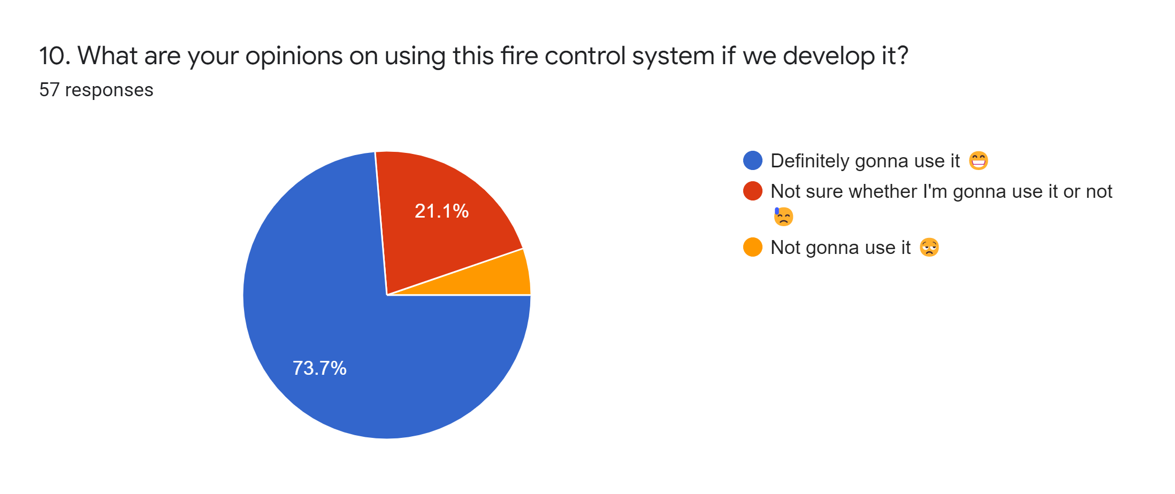

- GOALS AND BENEFITS OF PROJECT:

Fire alarm system plays an important role in maintaining and monitoring the safe of all kind environments and situations. However, the usability of many existing fire Alarm system is well known but could be produce with high cost or maybe it could be too complex to use. Subsequently, it is not affordable for the low-income users. So, the main goal of this project is to make a fire control system with low cost so that people can easily afford it and also can use it without any difficulties to understand. Additionally, if people have never used any technologies like that, it would be a great opportunity for them to get the best experience with a very minimum cost.
From our project, people will be benefited in so many ways. As this technology will allow people to locate location where fire erupted or occurred along with sound the alarm automatically if fire occurs. Moreover, this technology has an emergency servo motor to control the fire by supplying water to the area by motor pump. And lastly, it will have a feature by which the state of any room can be detected whether it is safe or not. So undoubtedly this project will be very helpful for everyone specially for people who work or live in such areas which are more likely to catch fire.

- PROTOTYPE BLOCK DIAGRAM:
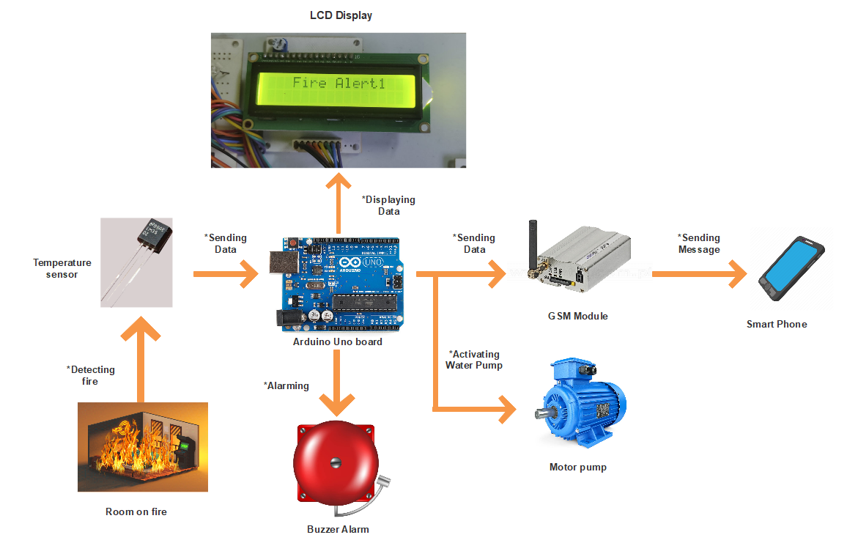
Figure 1: Block diagram of GSM based fire controlling system using Arduino uno board

- PROJECT TIMELINE (GANTT CHART):
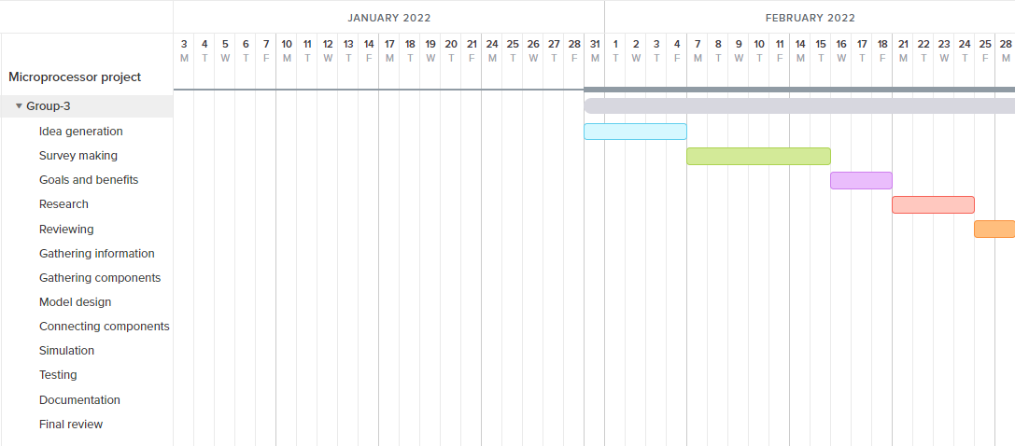
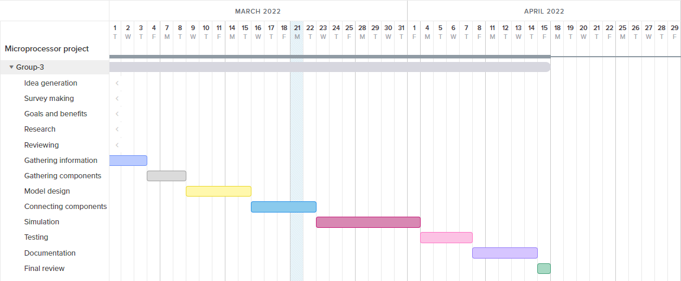
Figure 2: GANTT chart for GSM based fire controlling system using Arduino uno board

FOR FACULTY USE ONLY
COMMENTS BY COURSE TEACHER:

COURSE TEACHER’S NAME COURSE TEACHER’S SIGNATURE DATE

GROUP MEMBERS
(Maximum 8 students are permitted to carry out a single Project. However, depending on the capability of the students, 5 number of students may be allowed but not less than that)

NAME: CHOWDHURY, ANKETA  ID: 19-39514-1  PROGRAM: CSE  EMAIL: | NAME: SHAWON, EHSANUZZAMAN  ID: 19-39823-1  PROGRAM: CSE  EMAIL:
NAME: SAHA, ARNAB  ID: 19-39836-1  PROGRAM: CSE  EMAIL: | NAME: MARMA, WATHIN  ID: 19-40379-1  PROGRAM: CSE  EMAIL:
NAME: AHMED, NAFIZ  ID: 19-41283-3  PROGRAM: CSE  EMAIL: | NAME: SAHA, ANIK KUMAR  ID: 19-41289-3  PROGRAM: CSE  EMAIL:
NAME: AHMED, RAIYAN  ID: 19-41322-3  PROGRAM: CSE  EMAIL: | NAME: SIDDIQUE, RAIYAN KHADIZA  ID: 19-41456-3  PROGRAM: CSE  EMAIL:
REMARKS (for OFFICE use only)

